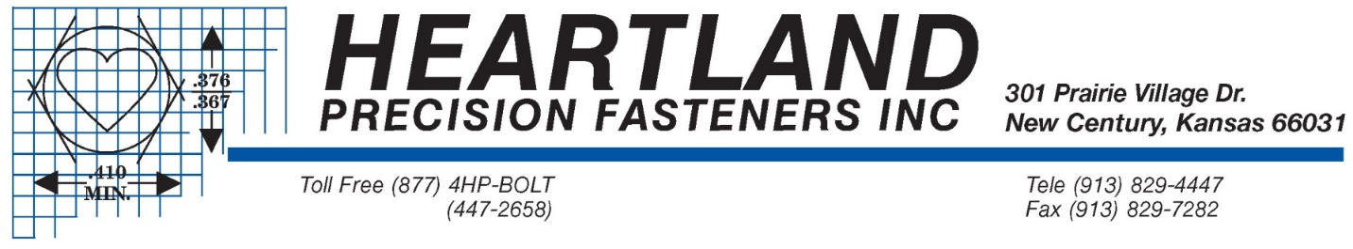

Employment Application

Applicant Information
Full Name: |  |  |  | Date:
 | Last | First | M.I.

Address:
 | Street Address | Apartment/Unit #

 | City | State | ZIP Code

Phone: |  | Email

Date Available: |  | Social Security No.: |  | Desired Salary: | $

Position Applied for:

Are you a citizen of the United States? | YES | NO | If no, are you authorized to work in the U.S.? | YES | NO

Have you ever worked for this company? | YES | NO | If yes, when?

Best time to contact you: ______________am / pm

Do you have friends and/or relatives currently working at Heartland? ________________________________________

If yes, Name: ___________________________________ Relationship: ____________________________________

Are you currently employed? ____________________ May we contact your present employer? _______________

Are you prevented from lawfully becoming employed in this country due to visa or immigration status? ______________

Are you available to work Full Time? (Please indicate 1st 2nd or 3rd shift)

Part-Time? (Please indicate: Mornings Afternoon Evenings)

Temporary? (Please indicate dates available: __________ ____________)

Are you currently on “lay-off” status and subject to recall? _____________________________________________________

Can you travel for your job if required? Yes No

Please list specialized skills, other job-related skills and qualifications, and professional trade and business activities and offices held:

Production Machinery: ____________________________ Calipers and Micrometers: _____________________________

Microsoft Office: _____________________________ Other: ________________________________________

Education

High School: |  | Address:

From: |  | To: |  | Did you graduate? | YES | NO | Diploma:

College: |  | Address:

From: |  | To: |  | Did you graduate? | YES | NO | Degree:

Other: |  | Address:

From: |  | To: |  | Did you graduate? | YES | NO | Degree:

References
Please list two professional references.

Full Name: |  | Relationship:
Company: |  | Phone:
Address:
Full Name: |  | Relationship:
Company: |  | Phone:
Address:

Previous Employment
Company: |  | Phone:
Address: |  | Supervisor:

Job Title: |  | Starting Salary: | $ | Ending Salary: | $

Responsibilities:

From: |  | To: |  | Reason for Leaving:

Company: |  | Phone:
Address: |  | Supervisor:

Job Title: |  | Starting Salary: | $ | Ending Salary: | $

Responsibilities:

From: |  | To: |  | Reason for Leaving:

Affirmation and Signature
AFFIRMATION I affirm that the facts set forth above in my application for employment are true, correct and complete to the best of my knowledge. I understand that I may be required to submit information not requested on this application form; that Heartland Precision Fasteners, Inc., may verify any information provided by me in the employment process; and that incomplete information or omission of my signature is just cause for rejection of my application. I understand and agree that, if hired, my employment would be contingent upon conditions specific to the position for which I am applying. I also understand that any omission of information, or erroneous information provided in any part of the employment process, would be sufficient cause for discharge

Signature: |  | Date:

FOR PERSONNEL DEPARTMENT USE ONLY

Position Applied for is Open? Yes No

Position Considered for?

Date: ___________________________________

